**3D graphs** in R using the package below:

* scatterplot3d, non interactive
* scatter3d, interactive
* rgl, interactive

To close the discussion about 3D, in this tutorial I’ll describe the impressive **plot3D** package and its extension **plot3Drgl**package.

**plot3D**, from Karline Soetaert, is an R package containing many functions for 2D and 3D plotting: *scatter3D*, *points3D*, *lines3D*,*text3D*, *ribbon3d*, *hist3D*, etc.

In addition to the x, y (and z) values, an **additional data dimension** can be represented by a color variable (argument *colvar*).

This **“4D”** plot (x, y, z, color) with a color legend is not (easily) possible using the packages mentioned above (scatterplot3d, scatter3d, rgl).

The package **plot3Drgl** allows to plot easily the graph generated with plot3D in openGL, as made available by package rgl. This is described at the end of the present article.

**Install plot3D package**

install.packages("plot3D")

**Load plot3D package**

**library**("plot3D")

**Prepare the data**

We’ll use the *iris* data set in the following examples :

data(iris)

**head**(iris)

Sepal.Length Sepal.Width Petal.Length Petal.Width Species

1 5.1 3.5 1.4 0.2 setosa

2 4.9 3.0 1.4 0.2 setosa

3 4.7 3.2 1.3 0.2 setosa

4 4.6 3.1 1.5 0.2 setosa

5 5.0 3.6 1.4 0.2 setosa

6 5.4 3.9 1.7 0.4 setosa

# x, y and z coordinates

x <- sep.l <- iris$Sepal.Length

y <- pet.l <- iris$Petal.Length

z <- sep.w <- iris$Sepal.Width

*iris* data set gives the measurements of the variables sepal length and width and petal length and width, respectively, for 50 flowers from each of 3 species of iris. The species are Iris setosa, versicolor, and virginica.

**Scatter plots**

**Functions for scatter plots and texts in 2D and 3D**

The function below will be used:

scatter3D(x, y, z, **...**, colvar = z, col = NULL, add = FALSE)

text3D(x, y, z, labels, colvar = NULL, add = FALSE)

points3D(x, y, z, **...**)

lines3D(x, y, z, **...**)

scatter2D(x, y, colvar = NULL, col = NULL, add = FALSE)

text2D(x, y, labels, colvar = NULL, col = NULL, add = FALSE)

* **x, y, z**: vectors of point coordinates
* **colvar**: a variable used for coloring
* **col**: color palette used for coloring the colvar variable
* **labels**: the text to be written
* **add**: logical. If TRUE, then the points will be added to the current plot. If FALSE a new plot is started
* **…**: additional *persp* arguments including xlim, ylim, zlim, xlab, ylab, zlab, main, sub, r, d, scale, expand, box, axes, nticks, tictype.

Note that:

* **points3D** and **lines3D** are shorthand for scatter3D(…, type =“p”) and scatter3D(…, type = “l”), respectively.
* **points2D** and **lines2D** are shorthand for scatter2D(…, type = “p”) and scatter2D(…, type =“l”), respectively.

**Basic scatter plot**

scatter3D(x, y, z, clab = c("Sepal", "Width (cm)"))

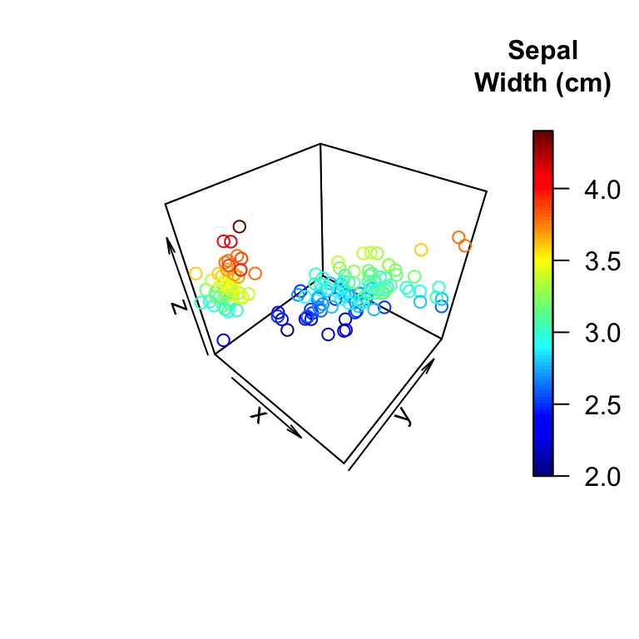

The argument *clab* is used to change the title of the color legend.

By default, the points are colored automatically using the variable *Z*

In the R code below:

* **colvar = NULL**: avoids coloring by z variable
* **col = “blue”**: changes point colors to blue
* **pch = 19**: changes point shapes
* **cex = 0.5**: changes the size of points

scatter3D(x, y, z, colvar = NULL, col = "blue",

pch = 19, cex = 0.5)

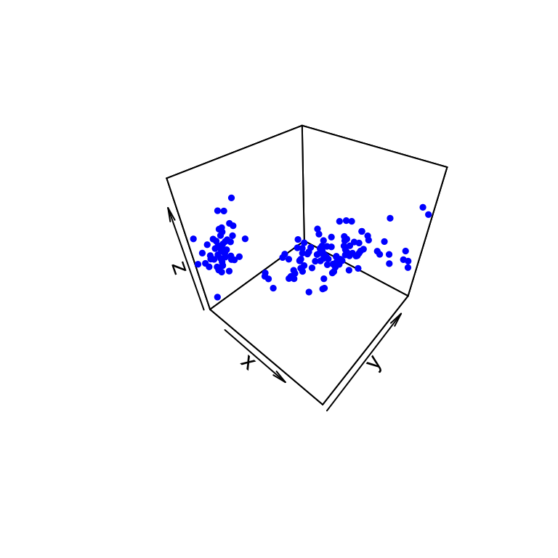

**Change the type of the box around the plot**

The argument **bty** is used. Allowed values are:

* “f”: full box
* “b”: default value. Only the back panels are visible
* “b2”: back panels and grid lines are visible
* “g”: grey background with white grid lines
* “bl”: black background
* “bl2”: black background with grey lines
* “u”: means that the user will specify the arguments col.axis, col.panel, lwd.panel, col.grid, lwd.grid manually
* “n”: no box will be drawn. This is the same as setting box = FALSE

# full box

scatter3D(x, y, z, bty = "f", colkey = FALSE, main ="bty= 'f'")

# back panels and grid lines are visible

scatter3D(x, y, z, bty = "b2", colkey = FALSE, main ="bty= 'b2'" )

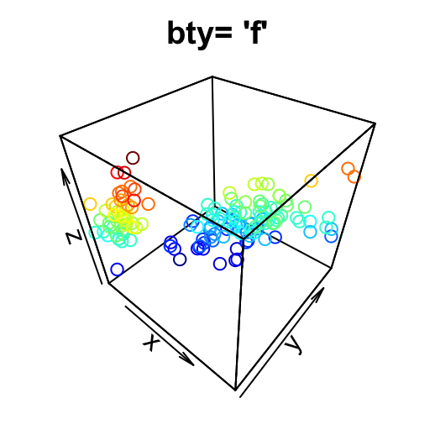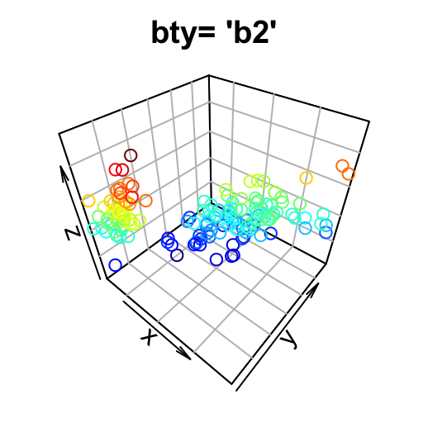

# grey background with white grid lines

scatter3D(x, y, z, bty = "g", colkey = FALSE, main ="bty= 'g'")

# User defined

scatter3D(x, y, z, pch = 18, bty = "u", colkey = FALSE,

main ="bty= 'u'", col.panel ="steelblue", expand =0.4,

col.grid = "darkblue")

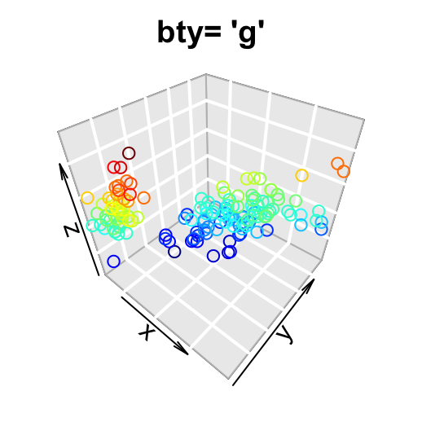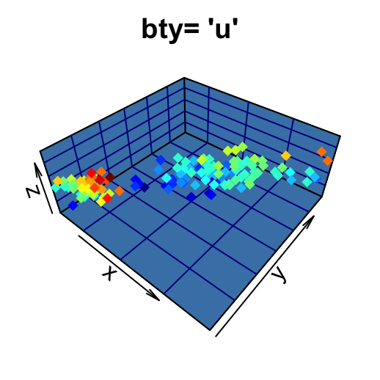

The argument **colkey = FALSE** is used to remove the legend.

**Color palettes**

Several color palettes are available in **plot3D** package:

* **jet.col(n, alpha)**: generates the matlab-type colors. This is the default color palette used in plot3D
* **jet2.col(n, alpha)**: similar to *jet.col()* but lacks the deep blue colors
* **gg.col(n, alpha)** and **gg2.col(n, alpha)** generates gg-plot-like colors
* **ramp.col(col = c(“grey”, “black”), n, alpha)**: creates color schemes by interpolation
* **alpha.col(col = “grey”, alpha)**: creates transparent colors
* **n**: Number of colors to generate. Default value is 100
* **alpha**: color transparency. Value in the range 0, 1. Default value is 1
* **col**: Colors to interpolate

# gg.col: ggplot2 like color

scatter3D(x, y, z, bty = "g", pch = 18, col = gg.col(100))

# ramp.col: custom palettes

scatter3D(x, y, z, bty = "g", pch = 18,

col = ramp.col(c("blue", "yellow", "red")) )

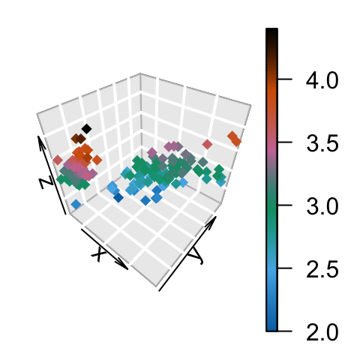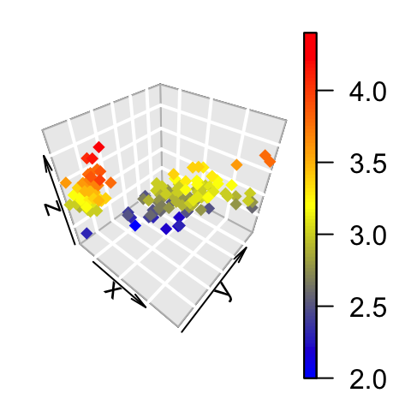

**Change the color by groups**

The **colkey** is customized (see **?colkey** for more details):

scatter3D(x, y, z, bty = "g", pch = 18,

col.var = as.integer(iris$Species),

col = c("#1B9E77", "#D95F02", "#7570B3"),

pch = 18, ticktype = "detailed",

colkey = list(at = c(2, 3, 4), side = 1,

addlines = TRUE, length = 0.5, width = 0.5,

labels = c("setosa", "versicolor", "virginica")) )

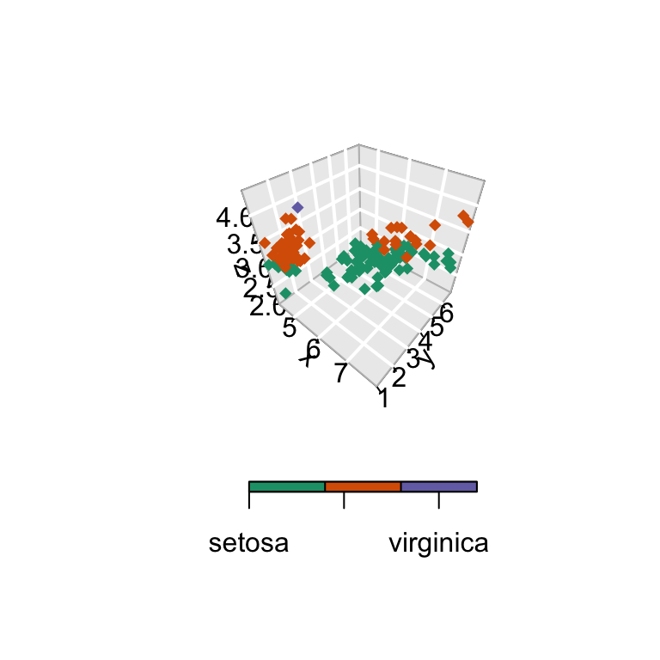

**Change the position of the legend**

# Bottom colkey

scatter3D(x, y, z, bty = "g",

colkey = list(side = 1, length = 0.5))

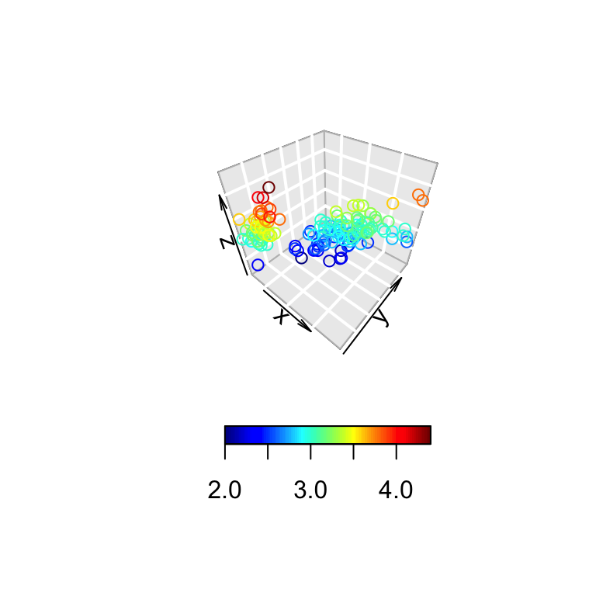

The argument *side* is used to specify the colkey position: 1: for bottom, 2: for left, 3: for top, 4: for right.

**3D viewing direction**

The arguments *theta* and *phi* can be used to define the angles for the viewing direction. *theta* is the azimuthal direction and *phi*the co-latitude.

scatter3D(x, y, z, theta = 15, phi = 20)

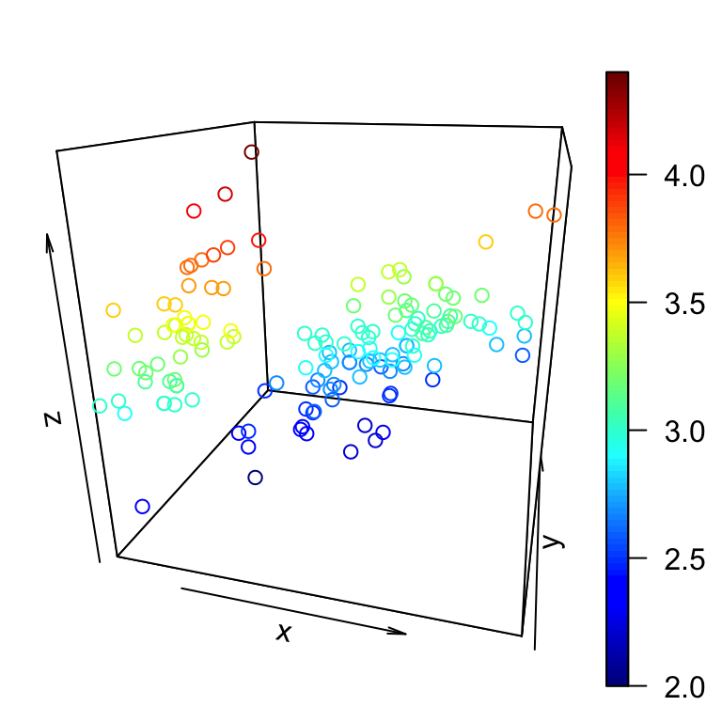

scatter3D(x, y, z, phi = 0, bty ="g")

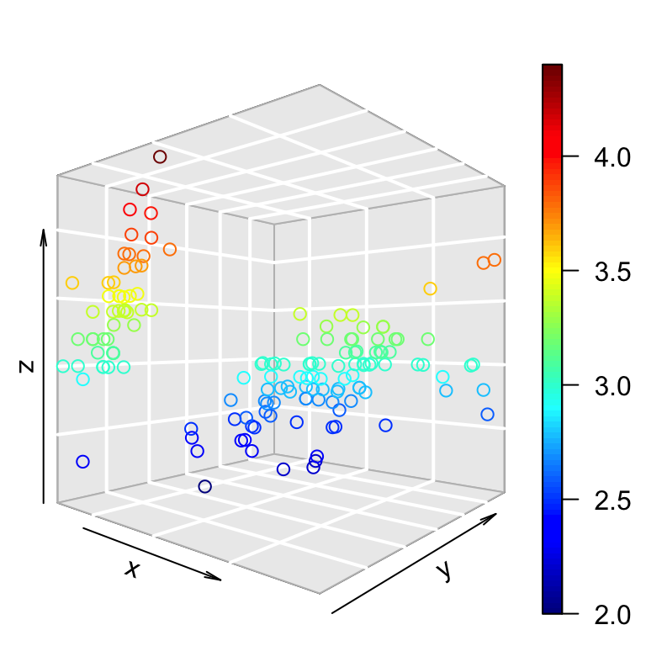

The default values for theta and phi are 40.

**Titles and axis labels**

scatter3D(x, y, z, pch = 18, theta = 20, phi = 20,

main = "Iris data", xlab = "Sepal.Length",

ylab ="Petal.Length", zlab = "Sepal.Width")

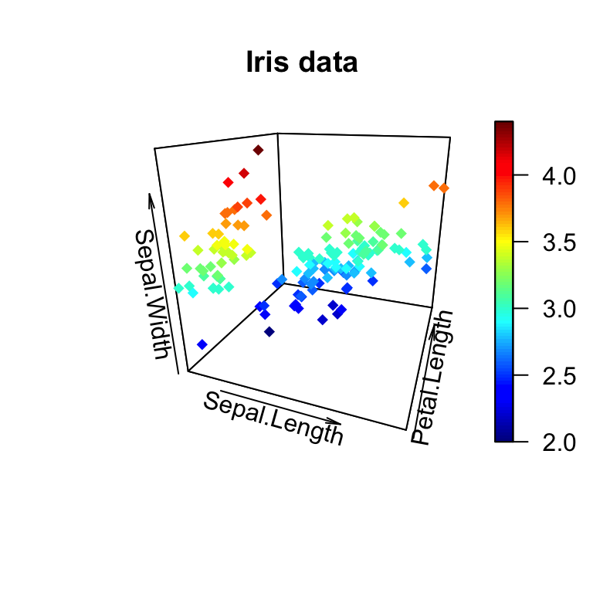

**Tick marks and labels**

The arguments below can be used:

1. **ticktype**: Possible values are

* *“simple”* draws just an arrow parallel to the axis to indicate direction of increase
* *“detailed”* draws normal ticks and labels

1. **nticks**: the number of tick marks to draw on the axes. It has no effect if ticktype =“simple”.

scatter3D(x, y, z, phi = 0, bty = "g",

pch = 20, cex = 2, ticktype = "detailed")

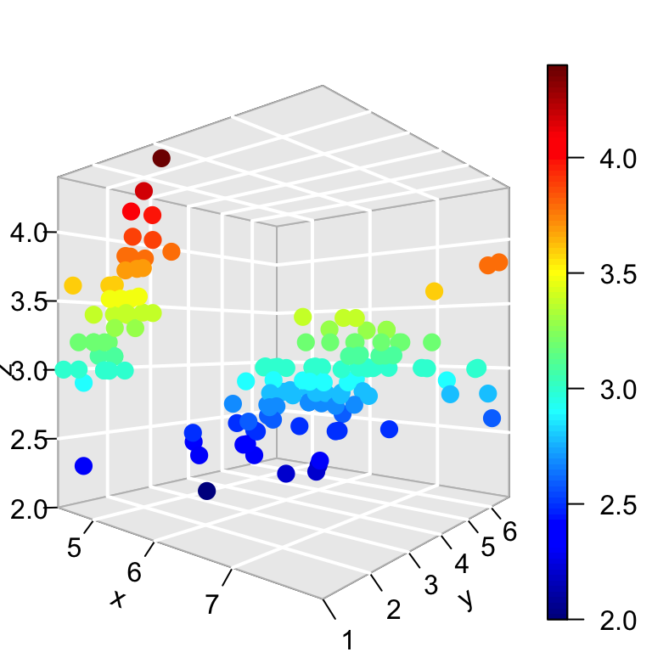

**Add points and text to an existing plot**

The functions below can be used:

* **scatter3D(x, y, z,…, add = TRUE)**: Adds points
* **text3D(x, y, z, labels, …, add = TRUE)**: Adds texts

1. **Add points** to an existing plot:

# Create a scatter plot

scatter3D(x, y, z, phi = 0, bty = "g",

pch = 20, cex = 2, ticktype = "detailed")

# Add another point (black color)

scatter3D(x = 7, y = 3, z = 3.5, add = TRUE, colkey = FALSE,

pch = 18, cex = 3, col = "black")

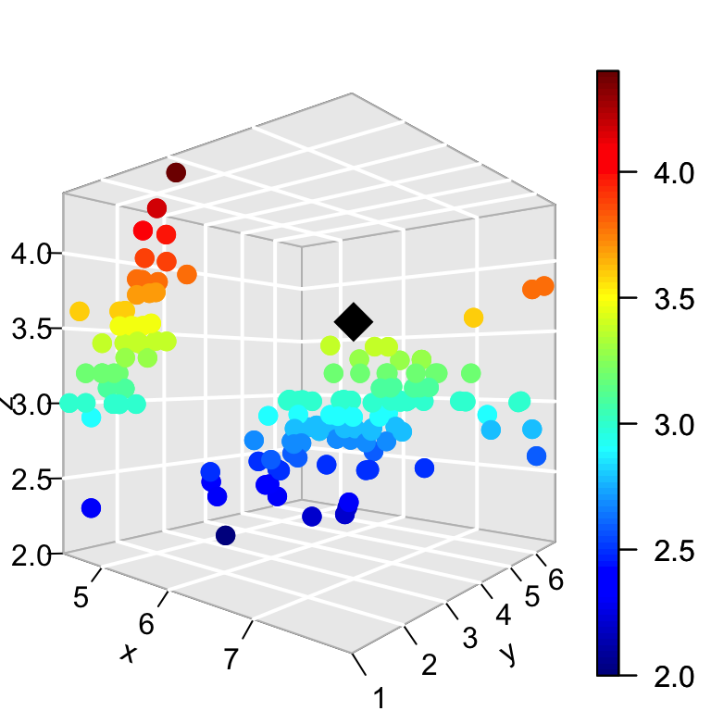

1. **Add texts** to an existing plot:

# Create a scatter plot

scatter3D(x, y, z, phi = 0, bty = "g", pch = 20, cex = 0.5)

# Add text

text3D(x, y, z, labels = rownames(iris),

add = TRUE, colkey = FALSE, cex = 0.5)

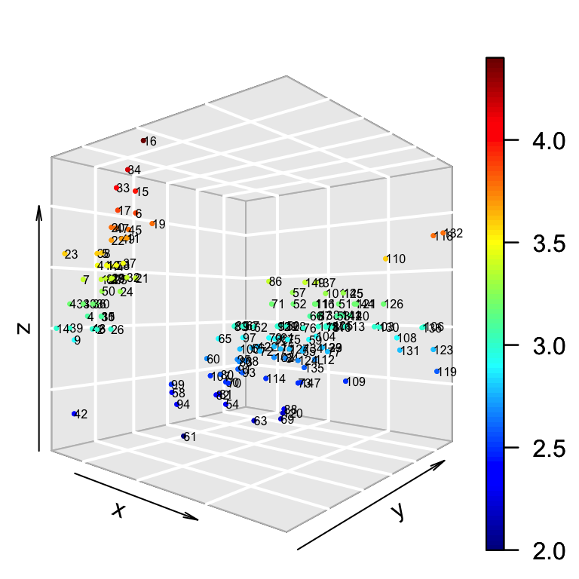

**Line plots**

# type ="l" for lines only

scatter3D(x, y, z, phi = 0, bty = "g", type = "l",

ticktype = "detailed", lwd = 4)

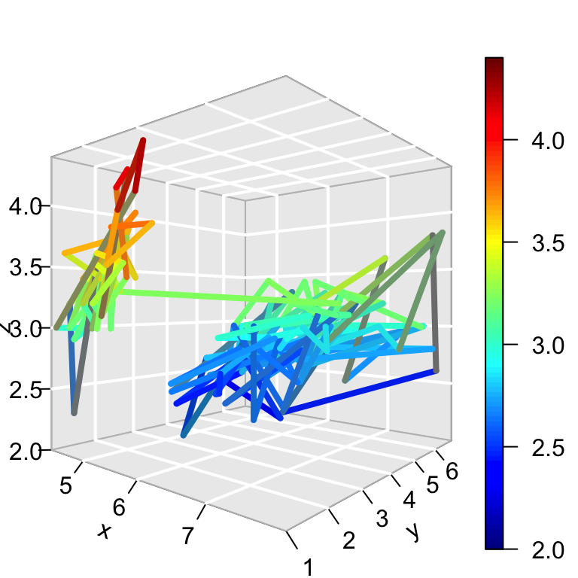

# type ="b" for both points and lines

scatter3D(x, y, z, phi = 0, bty = "g", type = "b",

ticktype = "detailed", pch = 20,

cex = c(0.5, 1, 1.5))

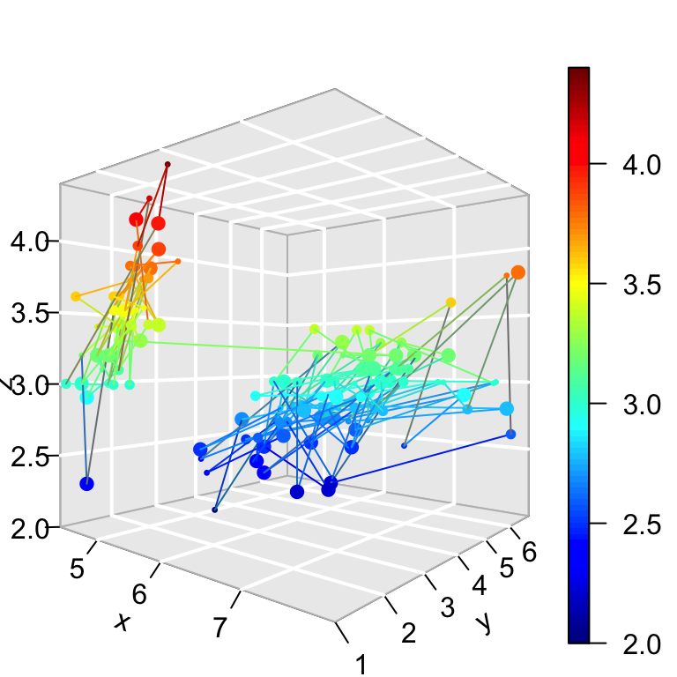

# type ="h" for vertical lines

scatter3D(x, y, z, phi = 0, bty = "g", type = "h",

ticktype = "detailed", pch = 19, cex = 0.5)

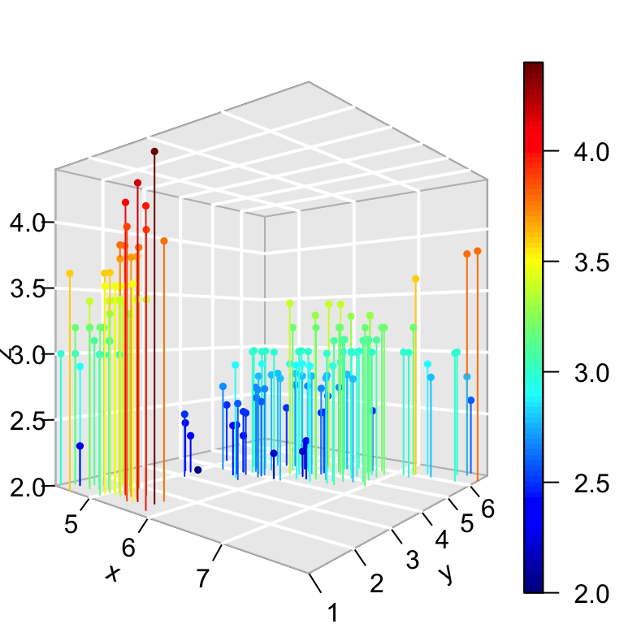

Vertical lines are useful to see clearly the x-y location of points.

**Add confidence interval**

The argument **CI** is used. It’s a list containing the parameters and values for the confidence intervals or NULL.

If *CI* is a list, it should contain at least the item x, y or z (latter for scatter3D).These should be 2-columned matrices, defining the left/right intervals.

Other parameters should be one of: alen = 0.01, lty = par(“lty”), lwd = par(“lwd”), col = NULL, to set the length of the arrow head, the line type and width, and the color.

If *col* is *NULL*, then the colors as specified by *colvar* are used.

# Confidence interval

CI <- list(z = matrix(nrow = length(x),

data = rep(0.1, 2*length(x))))

**head**(CI$z)

[,1] [,2]

[1,] 0.1 0.1

[2,] 0.1 0.1

[3,] 0.1 0.1

[4,] 0.1 0.1

[5,] 0.1 0.1

[6,] 0.1 0.1

# 3D Scatter plot with CI

scatter3D(x, y, z, phi = 0, bty = "g", col = gg.col(100),

pch = 18, CI = CI)

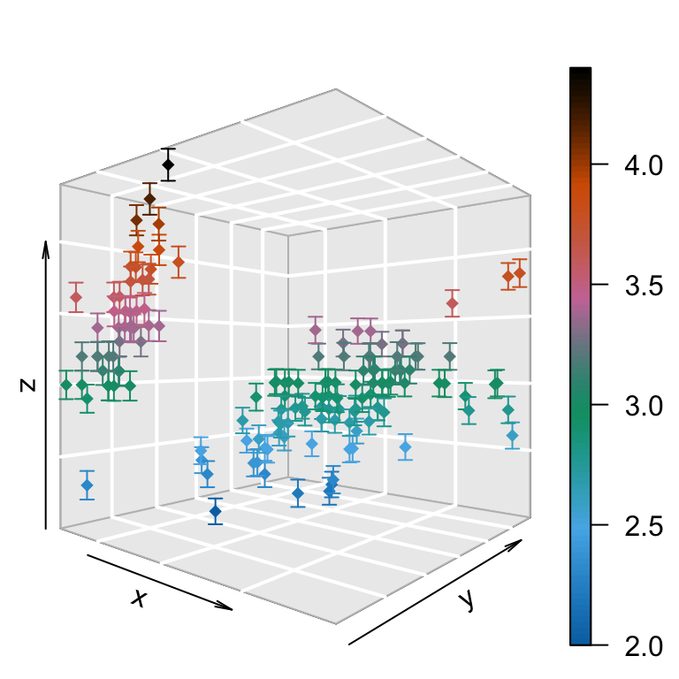

**3D fancy Scatter plot with small dots on basal plane**

A helper function **scatter3D_fancy()** is used:

# Add small dots on basal plane and on the depth plane

scatter3D_fancy <- **function**(x, y, z,**...**, colvar = z)

{

panelfirst <- **function**(pmat) {

XY <- trans3D(x, y, z = rep(min(z), length(z)), pmat = pmat)

scatter2D(XY$x, XY$y, colvar = colvar, pch = ".",

cex = 2, add = TRUE, colkey = FALSE)

XY <- trans3D(x = rep(min(x), length(x)), y, z, pmat = pmat)

scatter2D(XY$x, XY$y, colvar = colvar, pch = ".",

cex = 2, add = TRUE, colkey = FALSE)

}

scatter3D(x, y, z, **...**, colvar = colvar, panel.first=panelfirst,

colkey = list(length = 0.5, width = 0.5, cex.clab = 0.75))

}

Fancy scatter plot:

scatter3D_fancy(x, y, z, pch = 16,

ticktype = "detailed", theta = 15, d = 2,

main = "Iris data", clab = c("Petal", "Width (cm)") )

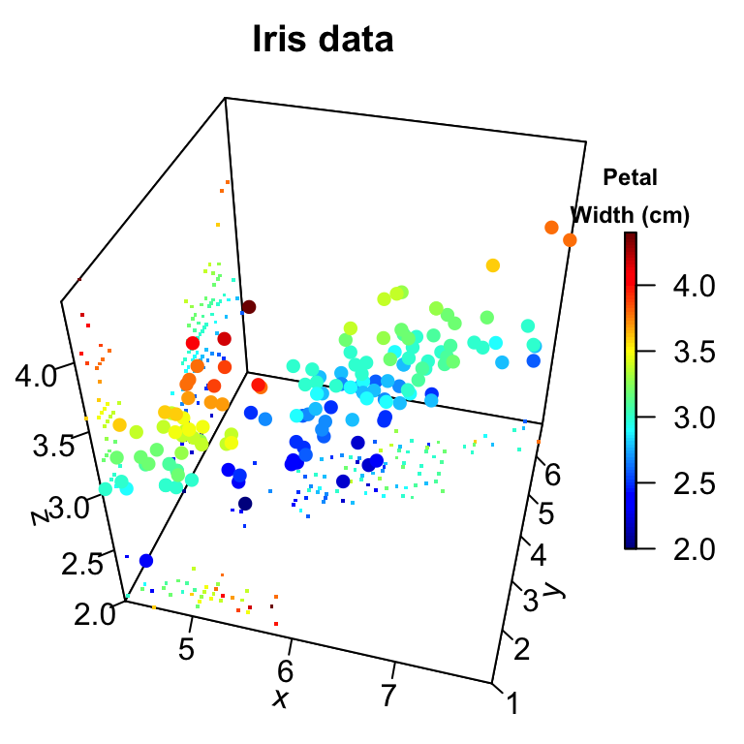

**Regression plane**

The mtcars data will be used:

data(mtcars)

**head**(mtcars[, 1:6])

mpg cyl disp hp drat wt

Mazda RX4 21.0 6 160 110 3.90 2.620

Mazda RX4 Wag 21.0 6 160 110 3.90 2.875

Datsun 710 22.8 4 108 93 3.85 2.320

Hornet 4 Drive 21.4 6 258 110 3.08 3.215

Hornet Sportabout 18.7 8 360 175 3.15 3.440

Valiant 18.1 6 225 105 2.76 3.460

1. Use the function *lm()* to compute a linear regression model: *ax + by + cz + d = 0*
2. Use the argument *surf* in **scatter3D()** function to add a regression surface.

# x, y, z variables

x <- mtcars$wt

y <- mtcars$disp

z <- mtcars$mpg

# Compute the linear regression (z = ax + by + d)

fit <- lm(z ~ x + y)

# predict values on regular xy grid

grid.lines = 26

x.pred <- seq(min(x), max(x), length.out = grid.lines)

y.pred <- seq(min(y), max(y), length.out = grid.lines)

xy <- expand.grid( x = x.pred, y = y.pred)

z.pred <- matrix(predict(fit, newdata = xy),

nrow = grid.lines, ncol = grid.lines)

# fitted points for droplines to surface

fitpoints <- predict(fit)

# scatter plot with regression plane

scatter3D(x, y, z, pch = 18, cex = 2,

theta = 20, phi = 20, ticktype = "detailed",

xlab = "wt", ylab = "disp", zlab = "mpg",

surf = list(x = x.pred, y = y.pred, z = z.pred,

facets = NA, fit = fitpoints), main = "mtcars")

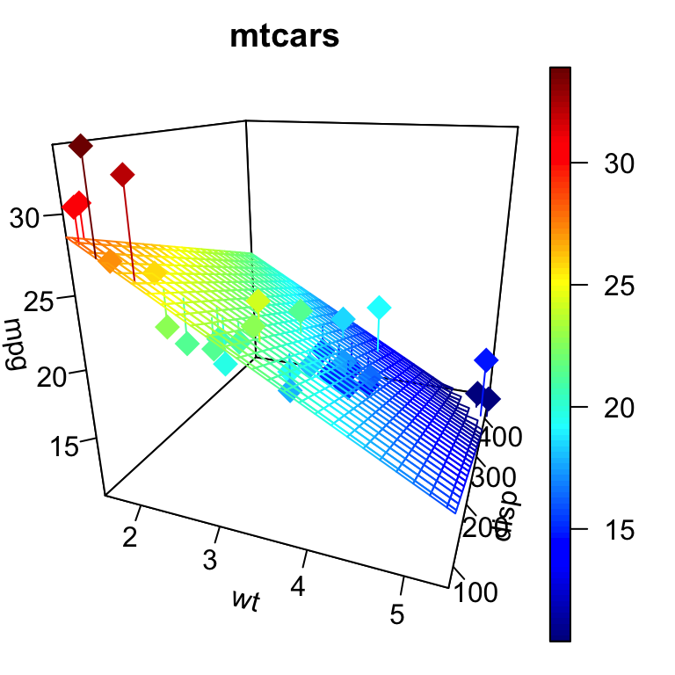

**surf** is a list specifying a (fitted) surface to be added on the scatter plot. The list should include at least x, y, z, defining the surface.

Other optional parameters can be specified in the *surf* argument including: colvar, col, NAcol, border, facets, lwd, resfac, clim, ltheta, lphi, shade, lighting, fit. (**see ?surf3D** for more details on these parameters)

* Note that, by default **colvar = z**.
* The argument **fit** should give the fitted *z-values*, in the same order as the z-values of the scatter points, for instance produced by *predict()*. When present, this will produce droplines from points to the fitted surface.

Note that, the function **expand.grid()**, in the R code above, creates a data frame from all combinations of factors

**text3D: plot 3-dimensionnal texts**

The function **text3D()** is used as follow:

text3D(x, y, z, labels, **...**)

The USArrests data sets will be used in the example below:

data(USArrests)

with(USArrests, text3D(Murder, Assault, Rape,

labels = rownames(USArrests), colvar = UrbanPop,

col = gg.col(100), theta = 60, phi = 20,

xlab = "Murder", ylab = "Assault", zlab = "Rape",

main = "USA arrests", cex = 0.6,

bty = "g", ticktype = "detailed", d = 2,

clab = c("Urban","Pop"), adj = 0.5, font = 2))

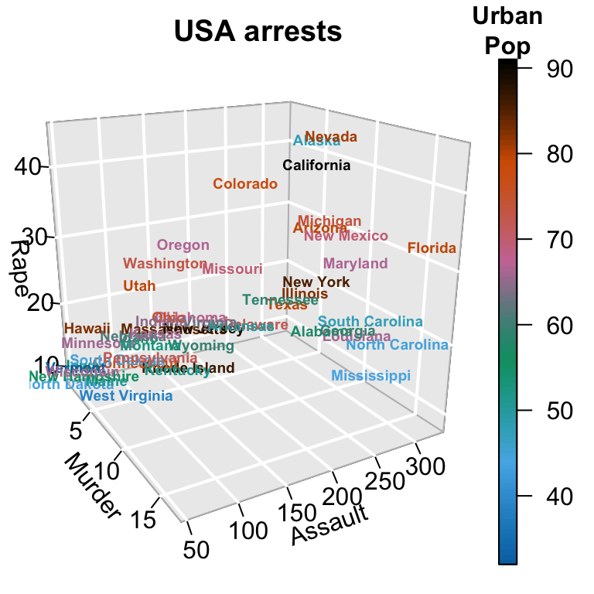

**text3D and scatter3D**

# Plot texts

with(USArrests, text3D(Murder, Assault, Rape,

labels = rownames(USArrests), colvar = UrbanPop,

col = gg.col(100), theta = 60, phi = 20,

xlab = "Murder", ylab = "Assault", zlab = "Rape",

main = "USA arrests", cex = 0.6,

bty = "g", ticktype = "detailed", d = 2,

clab = c("Urban","Pop"), adj = 0.5, font = 2))

# Add points

with(USArrests, scatter3D(Murder, Assault, Rape - 1,

colvar = UrbanPop, col = gg.col(100),

type = "h", pch = ".", add = TRUE))

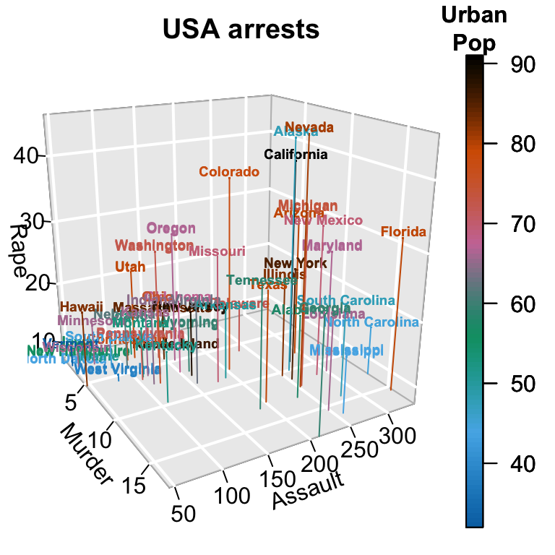

# Zoom near origin: choose suitable ranges

plotdev(xlim = c(0, 10), ylim = c(40, 150),

zlim = c(7, 25))

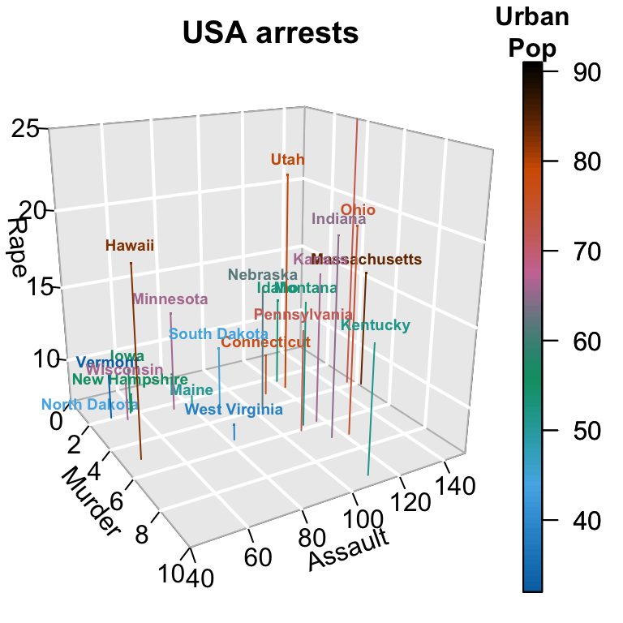

Note that, in order to choose suitable ranges for zooming, you can display axis ranges as follow:

# display axis ranges

getplist()[c("xlim","ylim","zlim")]

$xlim

[1] 0.8 17.4

$ylim

[1] 45 337

$zlim

[1] 7.3 46.0

**3D Histogram**

The function **hist3D()** is used:

hist3D (x, y, z, **...**, colvar = z,

col = NULL, add = FALSE)

* **z**: Matrix containing the values to be plotted
* **x, y** vectors with x and y values. *x* should be of length equal to nrow(z) and y should be equal to ncol(z)
* **colvar**: the variable used for coloring. If present, it should have the same dimension as z.
* **col**: color palette to be used for the colvar variable. By default a *red-yellow-blue* color scheme (?jet.col) is used
* **add**: Logical. If TRUE, then the surfaces will be added to the current plot. If FALSE a new plot is started.

data(VADeaths)

# hist3D and ribbon3D with greyish background, rotated, rescaled,...

hist3D(z = VADeaths, scale = FALSE, expand = 0.01, bty = "g", phi = 20,

col = "#0072B2", border = "black", shade = 0.2, ltheta = 90,

space = 0.3, ticktype = "detailed", d = 2)

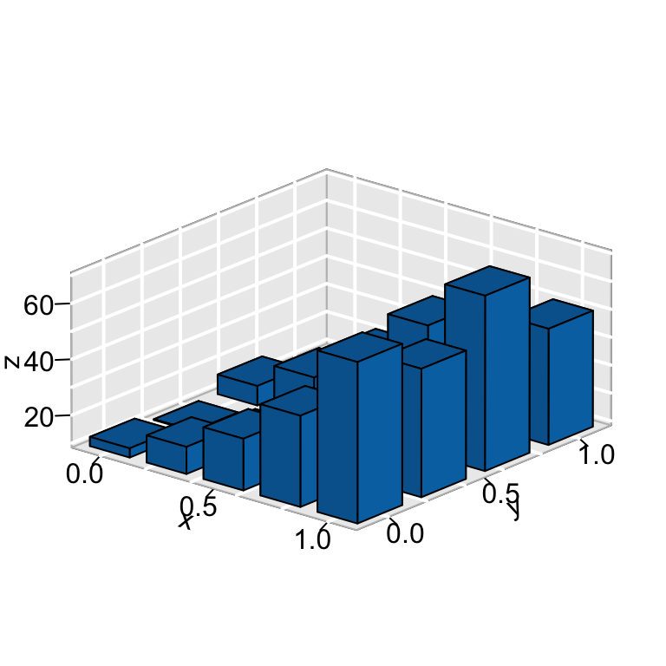

hist3D (x = 1:5, y = 1:4, z = VADeaths,

bty = "g", phi = 20, theta = -60,

xlab = "", ylab = "", zlab = "", main = "VADeaths",

col = "#0072B2", border = "black", shade = 0.8,

ticktype = "detailed", space = 0.15, d = 2, cex.axis = 1e-9)

# Use text3D to label x axis

text3D(x = 1:5, y = rep(0.5, 5), z = rep(3, 5),

labels = rownames(VADeaths),

add = TRUE, adj = 0)

# Use text3D to label y axis

text3D(x = rep(1, 4), y = 1:4, z = rep(0, 4),

labels = colnames(VADeaths),

add = TRUE, adj = 1)

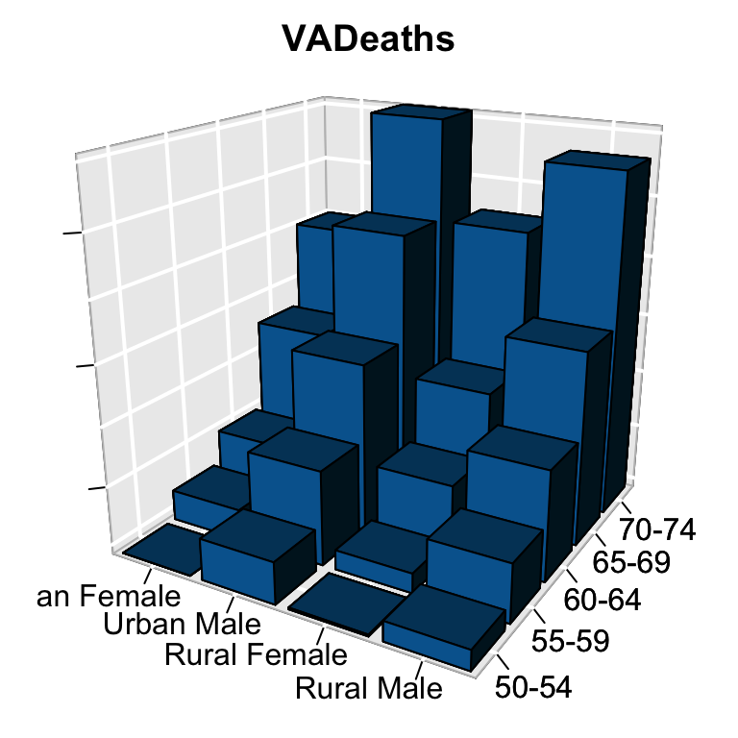

**fancy 3D** histograms

hist3D_fancy<- **function**(x, y, **break**.func = c("Sturges", "scott", "FD"), breaks = NULL,

colvar = NULL, col="white", clab=NULL, phi = 5, theta = 25, **...**){

# Compute the number of classes for a histogram

**break**.func <- **break**.func [1]

**if**(is.null(breaks)){

x.breaks <- **switch**(**break**.func,

Sturges = nclass.Sturges(x),

scott = nclass.scott(x),

FD = nclass.FD(x))

y.breaks <- **switch**(**break**.func,

Sturges = nclass.Sturges(y),

scott = nclass.scott(y),

FD = nclass.FD(y))

} **else** x.breaks <- y.breaks <- breaks

# Cut x and y variables in bins for counting

x.bin <- seq(min(x), max(x), length.out = x.breaks)

y.bin <- seq(min(y), max(y), length.out = y.breaks)

xy <- table(cut(x, x.bin), cut(y, y.bin))

z <- xy

xmid <- 0.5*(x.bin[-1] + x.bin[-length(x.bin)])

ymid <- 0.5*(y.bin[-1] + y.bin[-length(y.bin)])

oldmar <- par("mar")

par (mar = par("mar") + c(0, 0, 0, 2))

hist3D(x = xmid, y = ymid, z = xy, **...**,

zlim = c(-max(z)/2, max(z)), zlab = "counts", bty= "g",

phi = phi, theta = theta,

shade = 0.2, col = col, border = "black",

d = 1, ticktype = "detailed")

scatter3D(x, y,

z = rep(-max(z)/2, length.out = length(x)),

colvar = colvar, col = gg.col(100),

add = TRUE, pch = 18, clab = clab,

colkey = list(length = 0.5, width = 0.5,

dist = 0.05, cex.axis = 0.8, cex.clab = 0.8)

)

par(mar = oldmar)

}

hist3D_fancy(quakes$long, quakes$lat, colvar=quakes$depth,

breaks =30)

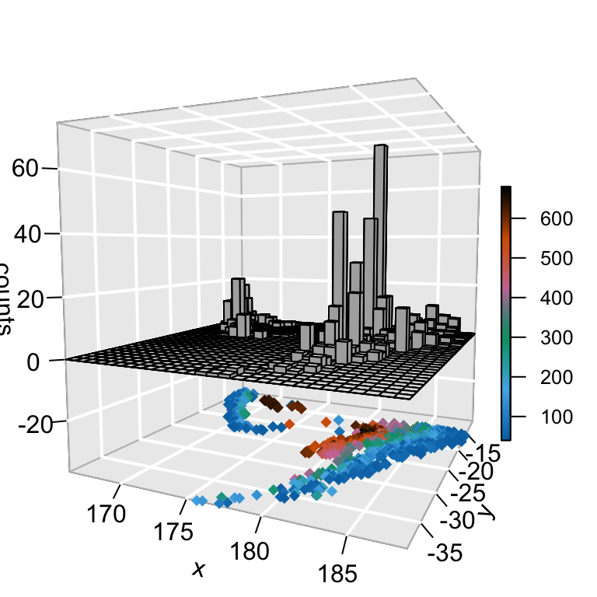

hist3D_fancy(iris$Sepal.Length, iris$Petal.Width,

colvar=as.numeric(iris$Species))

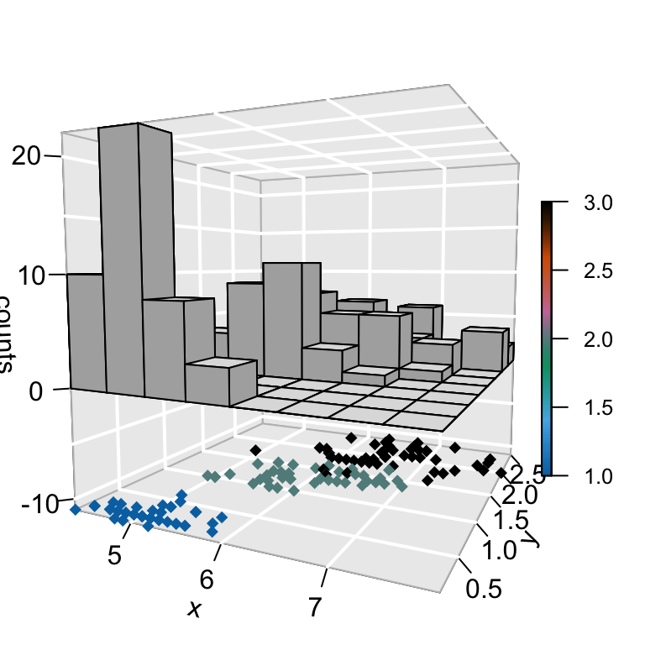

**scatter2D: 2D scatter plot**

**Create some data**:

# x, y coordinates

set.seed(1234)

x <- sort(rnorm(10))

y <- runif(10)

# Variable for coloring points

col.v <- sqrt(x^2 + y^2)

**Basic 2D scatter plot**:

scatter2D(x, y, colvar = col.v, pch = 16, bty ="n",

type ="b")

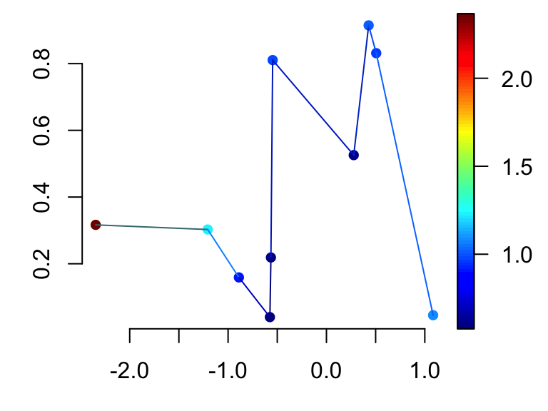

1. **type**: plot types. Allowed values are:

* **“b”** to draw both points and line
* **“h”** for vertical line
* **“l”** for line only
* **“p”** for points only

1. **bty**: box type

**2D scatter plot with confidence interval**:

# Confidence interval for x variable only

CI <- list()

CI$x <- matrix(nrow = length(x), data = c(rep(0.25, 2*length(x))))

scatter2D(x, y, colvar = col.v, pch = 16, bty ="n", cex = 1.5,

CI = CI, type = "b")

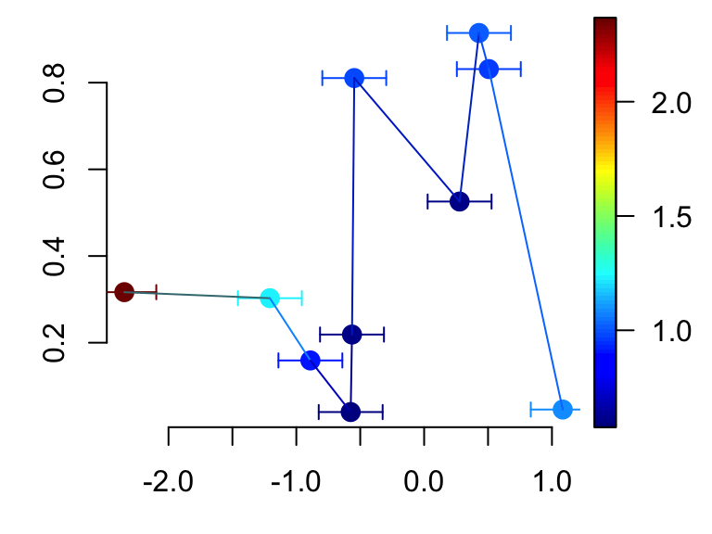

# Confidence interval for both x and y variables

CI$y <- matrix (nrow = length(y), data = c(rep(0.05, 2*length(y))))

CI$col <- "black"

scatter2D(x, y, colvar = col.v, pch = 16, bty ="n", cex = 1.5,

CI = CI, type ="b")

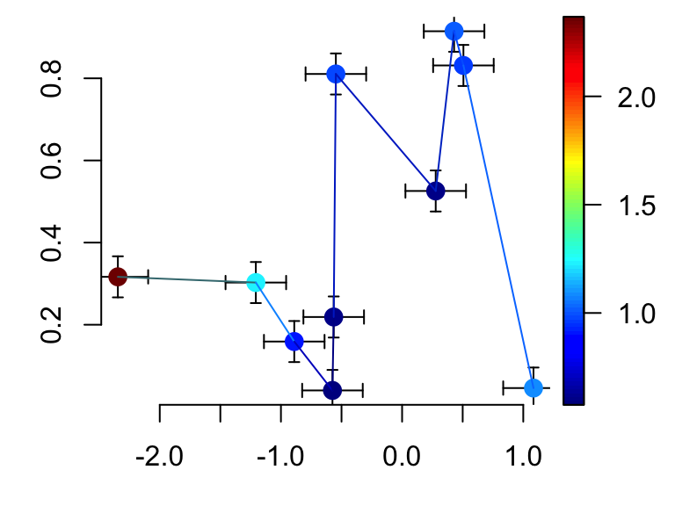

CI$y[c(2,4,8,10), ] <- NA # Some points have no CI

CI$x[c(2,4,8,10), ] <- NA # Some points have no CI

CI$alen <- 0.02 # increase arrow head

scatter2D(x, y, colvar = col.v, pch = 16, bty ="n", cex = 1.5,

CI = CI, type ="b")

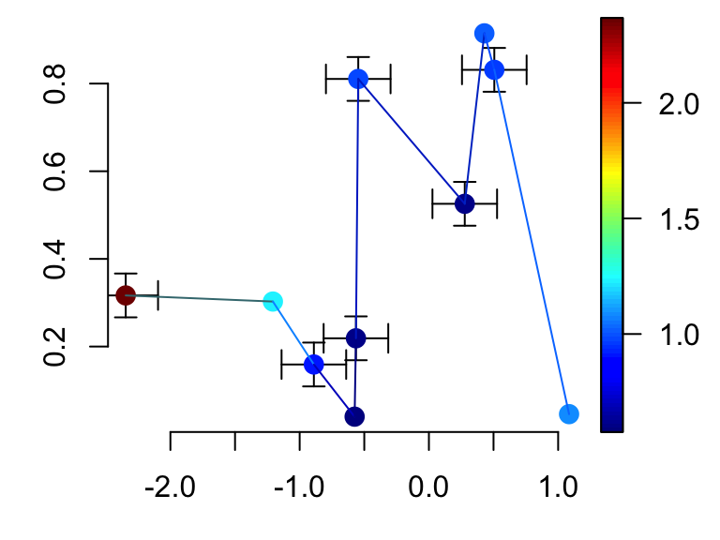

**text2D**

# Only text

with(USArrests, text2D(x = Murder, y = Assault + 5, colvar = Rape,

xlab = "Murder", ylab = "Assault", clab = "Rape",

main = "USA arrests", labels = rownames(USArrests), cex = 0.6,

adj = 0.5, font = 2))

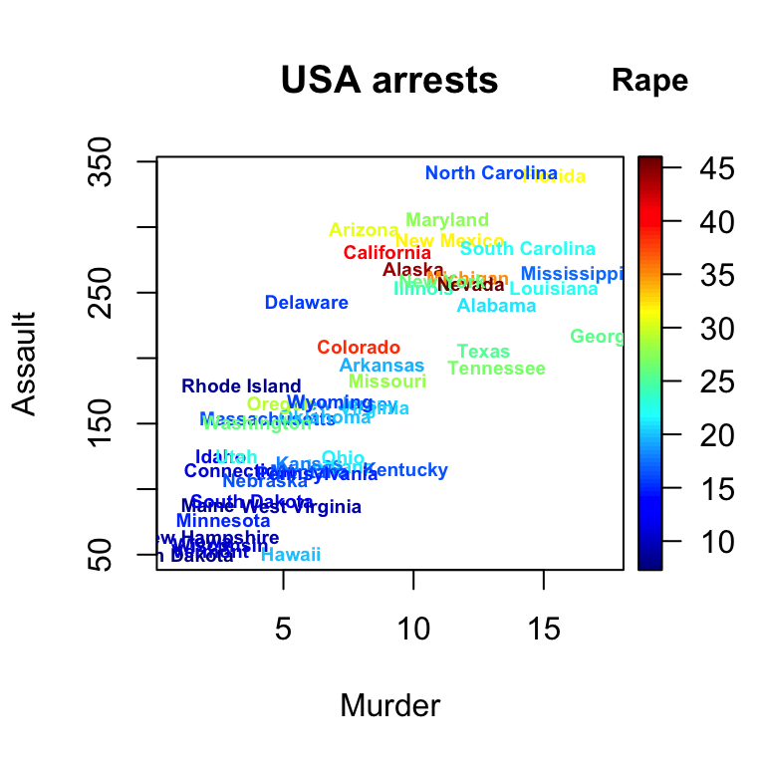

# text with point

with(USArrests, text2D(x = Murder, y = Assault + 5, colvar = Rape,

xlab = "Murder", ylab = "Assault", clab = "Rape",

main = "USA arrests", labels = rownames(USArrests), cex = 0.6,

adj = 0.5, font = 2))

with(USArrests, scatter2D(x = Murder, y = Assault, colvar = Rape,

pch = 16, add = TRUE, colkey = FALSE))

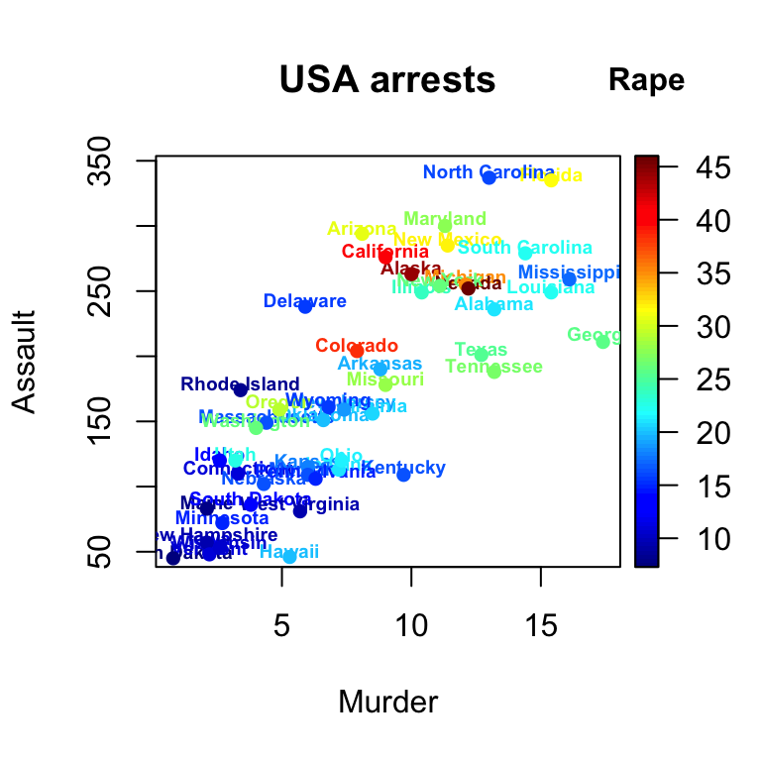

**Other functions**

It’s also possible to draw arrows, segments and rectangles in a 3D or 2D plot using the functions below:

arrows3D(x0, y0, z0, x1, y1, z1, **...**, colvar = NULL,

col = NULL, type = "triangle", add = FALSE)

segments3D(x0, y0, z0, x1, y1, z1, **...**, colvar = NULL,

col = NULL, add = "FALSE")

rect3D(x0, y0, y0, x1, y1, z1, **...**, colvar = NULL,

col = NULL, add = FALSE)

arrows2D(x0, y0, z0, x1, y1, z1, **...**, colvar = NULL,

col = NULL, type = "triangle", add = FALSE)

segments2D(x0, y0, z0, x1, y1, z1, **...**, colvar = NULL,

col = NULL, add = "FALSE")

rect2D(x0, y0, y0, x1, y1, z1, **...**, colvar = NULL,

col = NULL, add = FALSE)

* **x0, y0, z0**: coordinates of points from which to draw
* **x1**, **y1**, **z1**: coordinates of points to which to draw. For arrows3D and segments3D, at least one must be supplied. For rect3D exactly one must be NULL.
* **colvar**: The variable used for coloring.
* **col**: color palette to be used for coloring. Default is *red-yellow-blue* color scheme.
* **add**: Logical. If TRUE, then the arrows, segments, … will be added to the current plot. If FALSE a new plot is started.

Prepare the data: we want to plot 4 arrows starting from the point of coordinates c(x0, y0, z0) and ending at c(x1, y1, z1)

x0 <- c(0, 0, 0, 0)

y0 <- c(0, 0, 0, 0)

z0 <- c(0, 0, 0, 0)

x1 <- c(0.89, -0.46, 0.99, 0.96)

y1 <- c(0.36, 0.88, 0.02, 0.06)

z1 <- c(-0.28, 0.09, 0.05, 0.24)

cols <- c("#1B9E77", "#D95F02", "#7570B3", "#E7298A")

**3D Arrows**:

arrows3D(x0, y0, z0, x1, y1, z1, colvar = x1^2, col = cols,

lwd = 2, d = 3, clab = c("Quality", "score"),

main = "Arrows 3D", bty ="g", ticktype = "detailed")

# Add starting point of arrow

points3D(x0, y0, z0, add = TRUE, col="darkred",

colkey = FALSE, pch = 19, cex = 1)

# Add labels to the arrows

text3D(x1, y1, z1, c("Sepal.L", "Sepal.W", "Petal.L", "Petal.W"),

colvar = x1^2, col = cols, add=TRUE, colkey = FALSE)

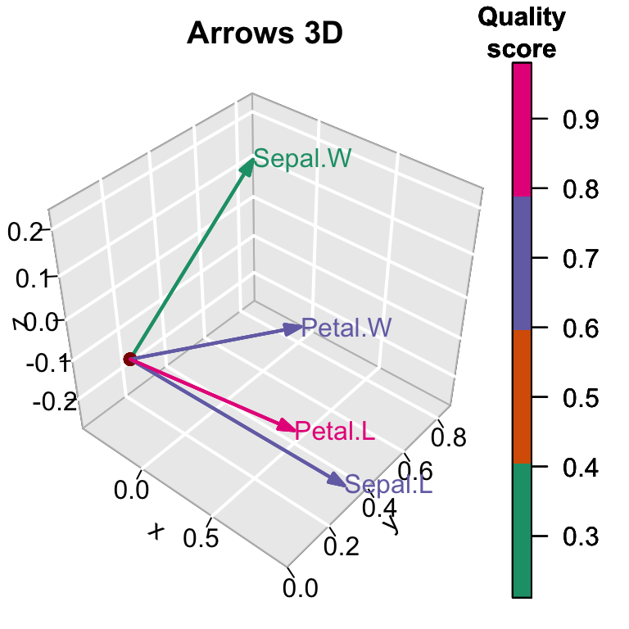

**2D arrows:**

arrows2D(x0, y0, x1, y1, colvar = x1^2, col = cols,

lwd = 2, clab = c("Quality", "score"),

bty ="n", xlim = c(-1, 1), ylim = c(-1, 1))

# Add vertical and horizontal lines at c(0,0)

abline(h =0, v = 0, lty = 2)

# Add starting point of arrow

points2D(x0, y0, add = TRUE, col="darkred",

colkey = FALSE, pch = 19, cex = 1)

# Add labels to the arrows

text2D(x1, y1, c("Sepal.L", "Sepal.W", "Petal.L", "Petal.W"),

colvar = x1^2, col = cols, add=TRUE, colkey = FALSE)

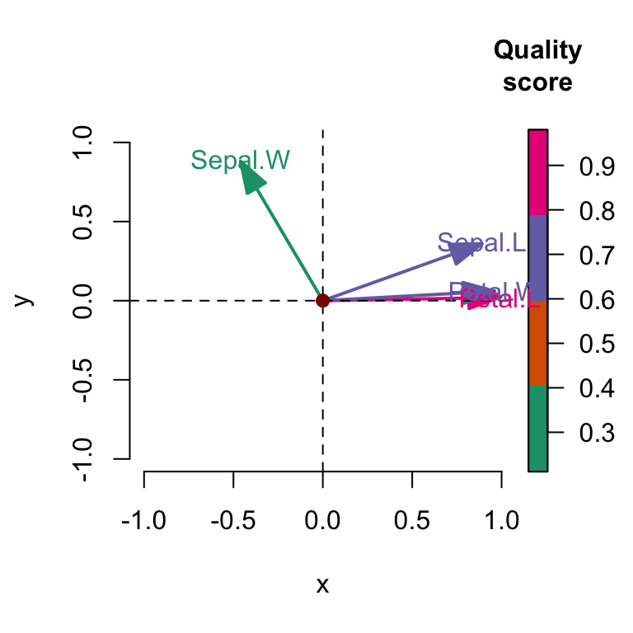

Note that, **segments3D()** and **segments2D()** are very similar to **arrows3D()** and **arrows2D()** and you can play with them also.

**3D rectangle**: the R code below creates a rectangle with a transparent fill color (alpha = 0.5)

rect3D(x0 = 0, y0 = 0.5, z0 = 0, x1 = 1, z1 = 5,

ylim = c(0, 1), bty = "g", facets = TRUE,

border = "red", col ="#7570B3", alpha=0.5,

lwd = 2, phi = 20)

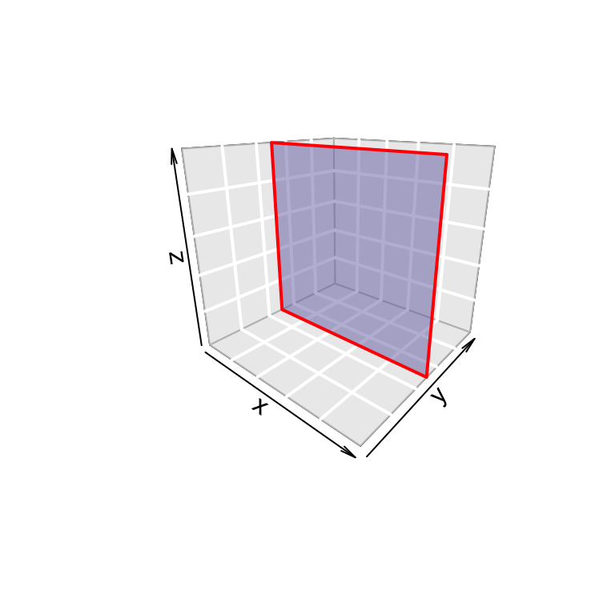

In the R code above, *facets = FALSE*, will remove the rectangle fill color.

**2D rectangle**:

rect2D(x0 = runif(3), y0 = runif(3),

x1 = runif(3), y1 = runif(3), colvar = 1:3,

alpha = 0.4, lwd = 2, main = "rect2D")

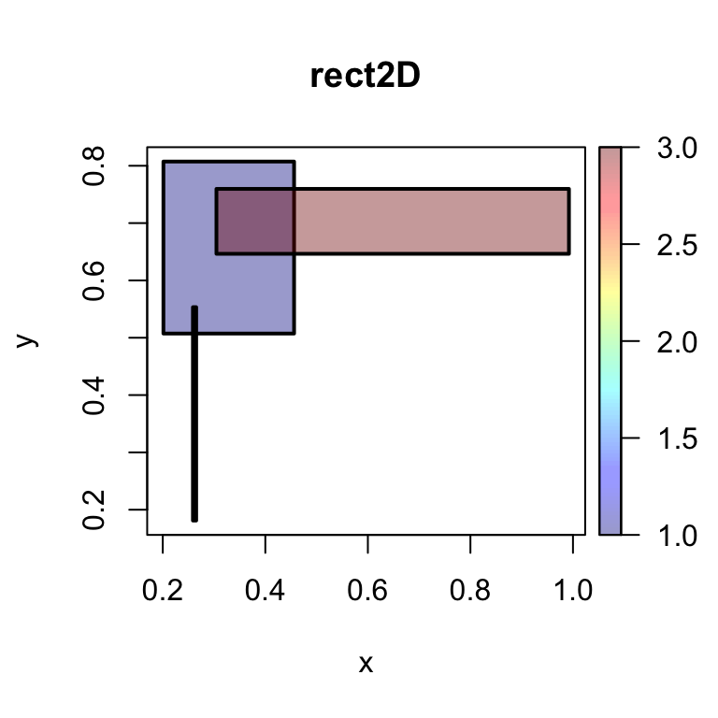

**Interactive plot**

To draw an interactive **3D plot** the package **plot3Drgl** can be used.

The package **plot3Drgl** allows to plot the graph generated with **plot3D** in openGL, as made available by package rgl.

The simplest way is to do as follow:

1. Create base R-graphics using plot3D package
2. Then use the function plotrgl() to draw the same figure in rgl

The package **rgl** allows to interactively rotate, zoom the graphs. However it’s not yet possible to plot a colorkey

# Create his3D using plot3D

hist3D_fancy(iris$Sepal.Length, iris$Petal.Width, colvar=as.numeric(iris$Species))

# Make the rgl version

**library**("plot3Drgl")

plotrgl()

